Predictive Modelling and Profit Optimization for Multi-Channel Restaurant Operations
Dataset: SkyCity Auckland Restaurants and Bars

Project by Mr Sanu Mathew

Table of Contents

- Business Understanding – Objective of Study

- Data Understanding

- Data Preprocessing

- Exploratory Data Analysis (EDA)

- Feature Engineering

- Predictive Modelling

- Model Evaluation

- Scenario Simulation Engine

- Sensitivity Analysis

- Optimization Layer

- Streamlit Dashboard

- Business Understanding – Objective of Study

The Objective of the study is to develop a data-driven Restaurant profit Optimization system that helps management understand the key factors affecting profitability and make informed operational decisions. The project analyses restaurant performance across multiple sales channels including In-Store, Uber Eats, DoorDash, and Self-Delivery.
Using historical operational and financial data, the study aims to predict restaurant profitability, identify the most influential business drivers, and evaluate the impact of changes in demand, commission rates, delivery costs, and channel mix. Advanced machine learning models and simulation techniques are employed to support scenario analysis, risk assessment, and strategic decision-making.
The system provides executives with actionable recommendations through interactive dashboards, what-if simulations, sensitivity analysis, Monte Carlo risk analysis, break-even commission analysis, channel optimization, and an executive recommendation engine.
The ultimate goal is maximize profitability, improve channel allocation, reduce operational risk, and enable restaurants to make data-driven decisions for sustainable growth and competitive advantage.

- Data Understanding

The dataset used in this study contains information from 1,696 rows with 30 columns describing restaurant characteristics, operational performance, sales channels, and profitability measures. The data provides a comprehensive view of restaurant operations and financial performance across different cuisines, business segments, and geographic regions.
It includes information such as Average Order Value (AOV), Monthly Orders, Growth Factor, Commission Rate, Delivery Radius, Delivery Cost per order, revenue generated through different channels (In-Store, Uber Eats,DoorDash and Self-Delivery), and profitability measures.
The data also contains restaurant characteristics such as Cuisine Type, Business Segment, and Geographic Subregion, enabling analysis of performance across different market segments. Feature Engineering was performed to derive additional business metrics including channel shares, revenue ratios, profit margins, and delivery-related indicators.
Exploratory Data Analysis(EDA) was conducted to understand data distributions, identify outliers, detect missing values, examine correlations among variables, and assess the relationship between operational factors and profitability. These insights provided the foundation for building predictive models and optimization frameworks aimed at improving restaurant profitability and operational efficiency.

- Data Pre-processing
Data preprocessing was carried out to improve data quality and transform the raw data into a format suitable for exploratory analysis and machine learning modelling. Proper preprocessing ensured consistency, reduced noise, and enhanced the predictive capability of the models.

- Data Cleaning
The dataset was first cleaned for inconsistencies, duplicate records, and missing values. Any duplicate observations were removed to prevent bias, and the integrity of numerical and categorical variables were verified. Data types were checked to ensure that each variable was stored in an appropriate format.

- Handling Missing Values
Missing values were examined across all features. Since the dataset contained very few missing observations, appropriate treatments such as imputation and removal were applied where necessary to maintain data completeness and avoid information loss.

- Creation of Target Variable
The target variable used for prediction was TotalNetProfit, representing the overall profitability of each restaurant. This variable served as the dependent variable in the machine learning models developed during the study.

- Encoding of Categorical Variables.
Categorical variables such as:
    - Cuisine Type
    - Restaurant Segment
    - Subregion
Were transformed into numerical format using One-Hot Encoding. This conversion generated binary indicator variables for each category, enabling machine learning algorithms to process categorical information effectively
Examples include:
- CuisineType_Chinese
- CuisineType_Indian
- Segment_QSR
- Segment_Full-service
- Subregion_West_Auckland

- Feature Selection
Relevant features affecting restaurant profitability were selected based on business understanding and exploratory analysis. Variables related to revenues, costs, delivery channels, customer demand, and restaurant characteristics were retained, while identifiers such as RestaurantID and RestaurantName were excluded because they do not contribute to prediction.

- Train-Test Split
The pre-processed dataset was divided into training and testing subsets. Approximately 80% of the observations were used for model training, while the remaining 20% were reserved for evaluating model performance on unseen data.

- Preparation for Machine Learning
After preprocessing and feature engineering, the final dataset consisted of numerical variables only. The resulting dataset was suitable for training various regression models, including:

- Linear Regression
- Random Forest Regressor
- Gradient Boosting Regressor
- XGBoost Regressor

Importance of Data Pre-processing
Data preprocessing transformed the raw restaurant data into a structured and analysis-ready dataset. By cleaning the data, encoding categorical variables, selecting relevant attributes, and engineering informative features, the study improved model accuracy and enabled reliable prediction of restaurant profitability. Thes preprocessing steps formed the foundation for subsequent exploratory analysis, machine learning modelling, and optimization techniques employed in the project.

- Exploratory Data Analysis (EDA)
Exploratory Data Analysis(EDA) was performed to gain insights into the structure and characteristics of the restaurant dataset. The analysis included examining summary statistics, identifying missing values and outliers, and understanding the distributions of numerical variables. Correlation analysis was conducted to study the relationships between operational factors and profitability measures.
Various visualizations such as histograms, box plots, bar charts and heatmaps were used to explore patterns in revenue, orders, channel shares, and profit metrics. EDA helped uncover important business trends, assess data quality, and identify the key variables influencing restaurant profitability. These insights guided feature engineering and the development of predictive and optimization models used in the study.

UNIVARIATE-ANALYSIS:
Distribution of Average Order Value (AOV)
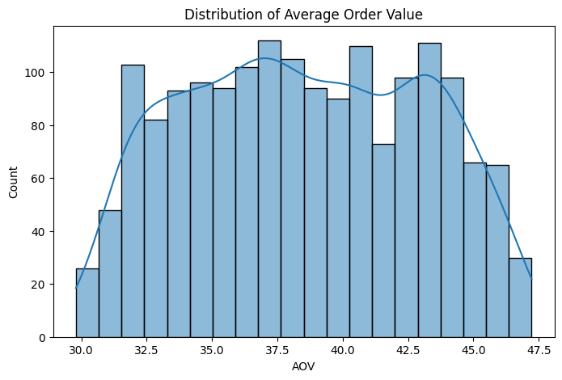

The histogram illustrates the distribution of Average Order Value(AOV) across the restaurants in the dataset. The AOV values range approximately from 30 to 47.5, with the majority of restaurants having and order value between 35 and 45. The distribution appears relatively symmetric and close to normal, indicating that most restaurants operate within a similar pricing range. There are no significant outliers or extreme values, suggesting consistency in customer spending patterns across the restaurants. This information provides valuable insight into pricing behaviour and serves as an important predictor of restaurant profitability.

Monthly Orders Distribution:
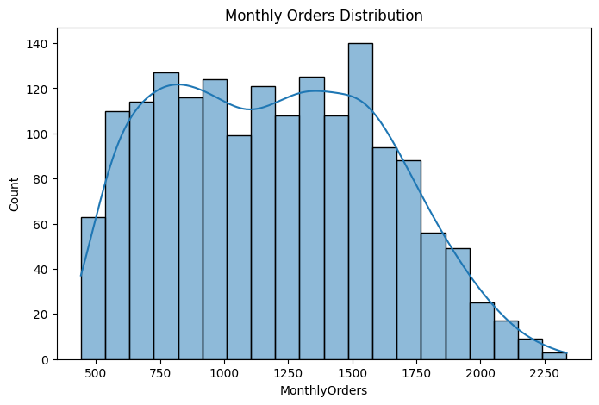
The histogram shows the distribution of monthly orders across restaurants in the dataset. Monthly order volumes range from approximately 400 to 2400 orders, with most restaurants receiving between 700 and 1,700 orders per month. The distribution exhibits a slight right skew, indicating that while most restaurants have moderate order volumes, a smaller number of restaurants experience slightly higher demand. The absence of extreme outliers suggests a relatively balanced customer demand pattern. Since order volume directly impacts revenue and profitability, Monthly Orders serves as one of the key drivers in the restaurant profit optimization model.

Commission Rate Distribution:
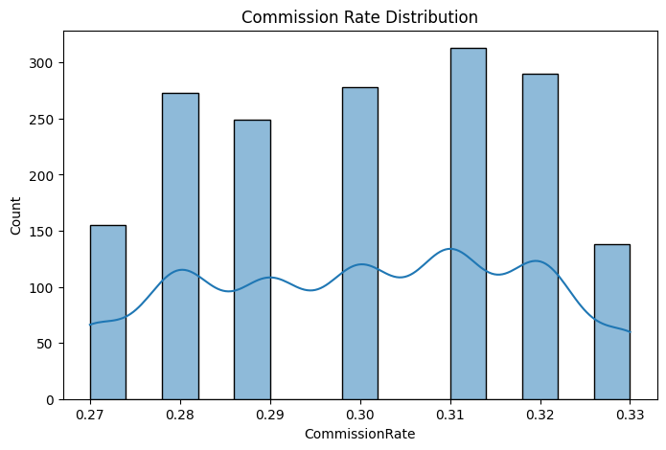

The histogram illustrates the distribution of commission rates charged by delivery platforms across restaurants. The commission rates range from approximately 27% to 33%, with the majority of restaurants operating within the 29% - 32% range. The distribution is fairly uniform, indicating that restaurants experience similar commission structures with only minor variations. Since commission fees directly affect profitability, understanding their distribution is important for evaluating platform costs and identifying opportunities for commission optimization and profit improvement.

Delivery Cost per Order Distribution:
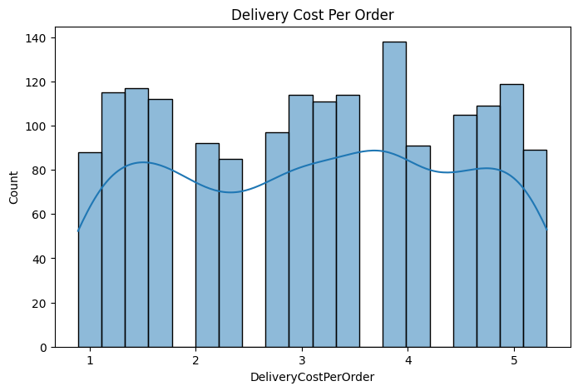
The histogram illustrates the distribution of delivery cost per order across restaurants in the dataset. Delivery costs range approximately from 1 to 5.5 units, with most observations concentrated between 1.5 and 5.0. The distribution appears fairly balanced, indicating moderate variability in delivery expenses among restaurants. No extreme outliers are observed, suggesting that delivery costs are relatively stable across the network. Since delivery expenses directly effect operating margins, understanding their distribution is important for evaluating cost efficiency and developing strategies to optimize profitability.

Delivery Radius Distribution:
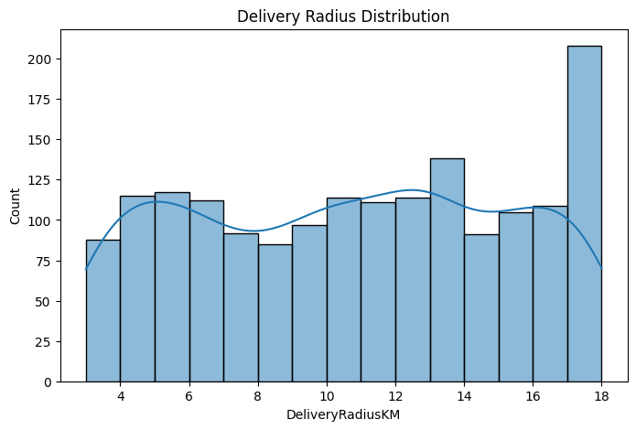

The histogram depicts the distribution of delivery radius across restaurants in the dataset. Delivery radius values range from approximately 3 km to 18 km, with most restaurants operating within a radius of 5 km to 17 km. The distribution is relatively balanced, indicating variation in service coverage among restaurants without the presence of significant outliers. Larger delivery radii may help restaurants reach more customers but can also increase delivery costs and affect profitability. Therefore, delivery radius is an important operational factor in optimizing restaurant performance and delivery efficiency.

Cuisine Type Distribution
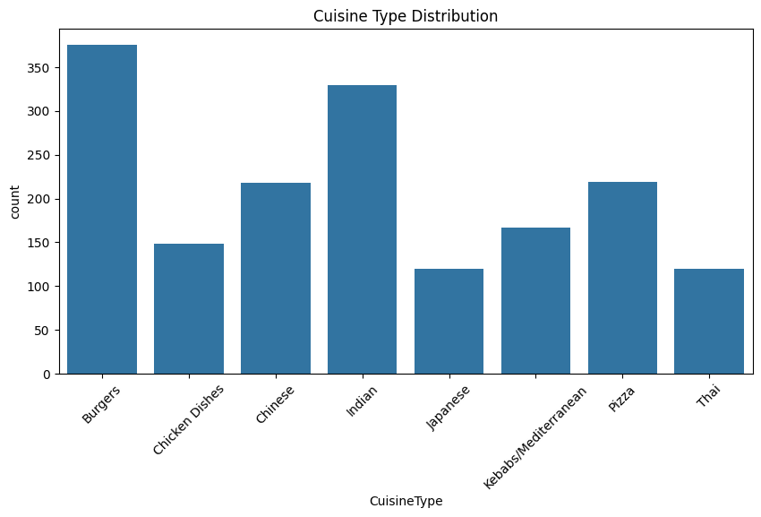

The bar chart illustrates the distribution of restaurants across different cuisine types. Burgers represent the largest category, followed by Indian cuisine, indicating their strong presence in the dataset. Chinese and Pizza restaurants also account for a significant proportion, while Japanese, Thai and Chinese Dishes have comparatively fewer restaurants. The variation in cuisine categories highlights the diversity of restaurant offerings and suggests that customer preferences and profitability may differ across cuisine segments. Understanding these patters can help business tailor strategies for specific market segments and optimize operational performance

Segment Distribution
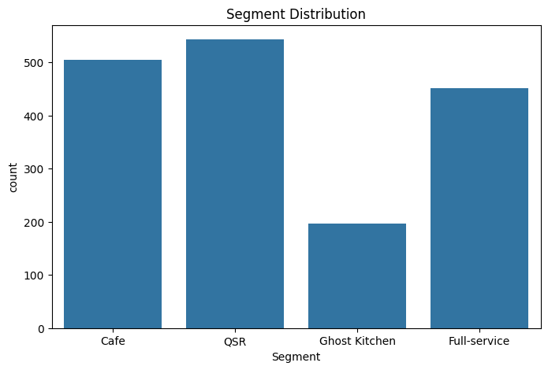
The bar chart shows the distribution of restaurants across different business segments. QSR(Quick Service Restaurants) constitute the largest segment in the dataset, followed closely by Cafes and Full-service restaurants. Ghost Kitchens represent the smallest segment, indicating relatively lower presence compared to traditional restaurant formats. The variation in segment composition reflects the diversity of business models within the industry and suggests that operational strategies and profitability drivers may differ across segments. Understanding these differences is important for developing targeted optimization and decision-making strategies.
Subregion Distribution
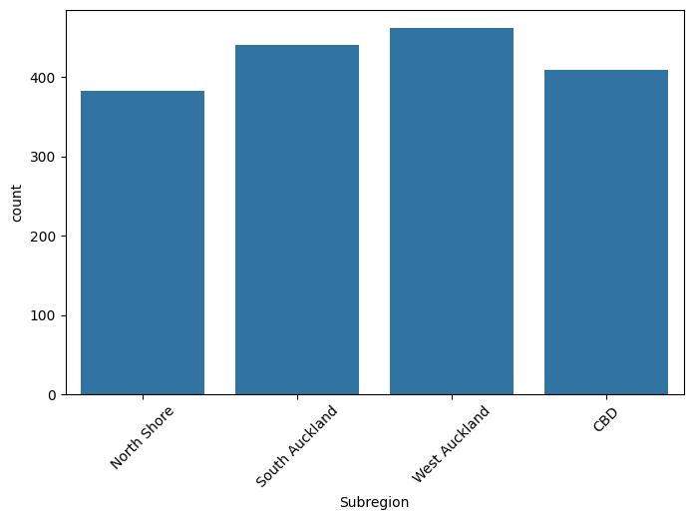

The bar chart presents the distribution of restaurants across different geographic subregions. West Auckland has the highest number of restaurants, followed by South Auckland, while CBD and North Shore have relatively fewer establishments. The differences in restaurant concentration indicate varying levels of market presence and customer demand across regions. Understanding the geographic distribution of restaurants is important for identifying growth opportunities, optimizing resource allocation, and developing region-specific business strategies to enhance profitability and operational efficiency.
BIVARIATE-ANALYSIS:

Relationship between Average Order Value and Monthly Orders
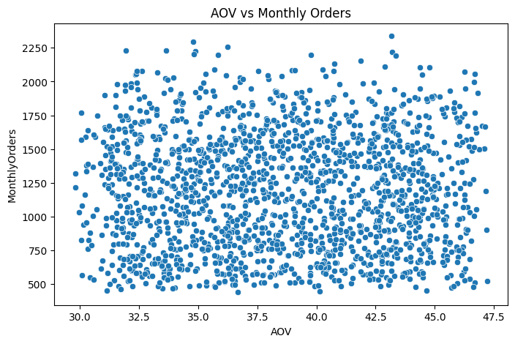
The scatter plot illustrates the relationship between Average Order Value (AOV) and Monthly Orders across restaurants. The data points are widely dispersed, indicating that there is no strong linear relationship between the two variables. Restaurants with both low and high AOI values exhibit a broad range of monthly order volumes, suggesting that higher order values do not necessarily correspond to higher demand. This implies that factors other than pricing, such as customer preferences, location, cuisine type, and channel mix, may play a significant role in influencing order volume and overall profitability.

Relationship between Commission Rate and Uber Eats Profit
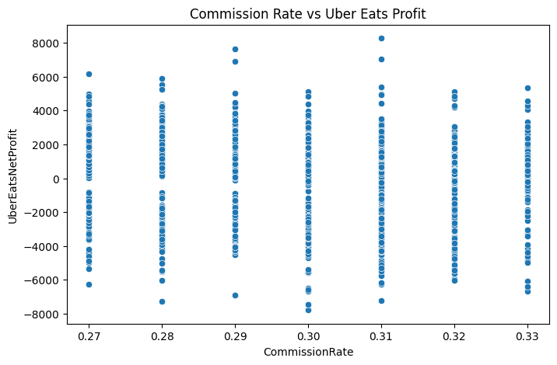
The scatter plot illustrates the relationship between Commission Rate and Uber Eats Net Profit across restaurants. The data points are widely dispersed, with profits ranging from substantial losses to significant gains at each commission level. This indicates that there is no clear linear relationship between commission rate and Uber Eats profitability. While higher commission rate increase platform costs, other factors such as order volume, average order value, and operating efficiency also influence overall profit. The wide variation in profits suggests that commission rate alone is not sufficient to explain restaurant performance on the Uber Eats channel.

Relationship between Delivery Cost and Self-Delivery Profit
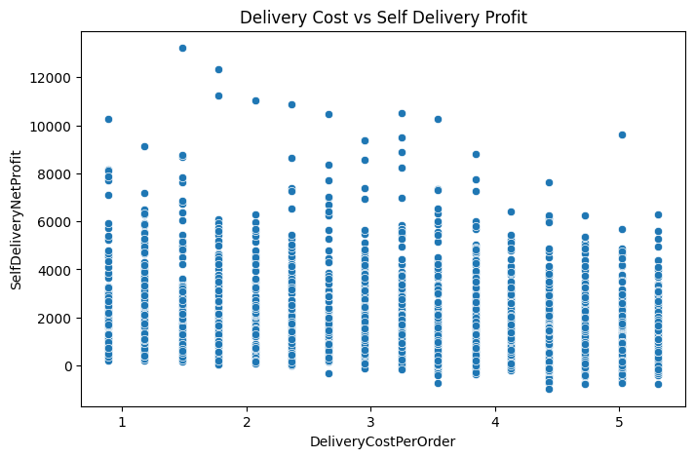
The scatter plot shows the relationship between Delivery Cost per Order and Self-Delivery Net Profit across restaurants. The data points are widely dispersed, indicating considerable variability in profitability at different delivery cost levels. While some restaurants achieve high self-delivery profits at lower delivery costs, profits generally tend to decline as delivery costs increase. The presence of both positive and negative profits suggests that delivery expenses significantly influence self-delivery performance, although other factors such as order volume and average order value also contribute to profitability. Overall, the chart highlights the importance of controlling delivery costs to maintain and improve self-delivery margins.

Relationship between Growth Factor and Monthly Orders
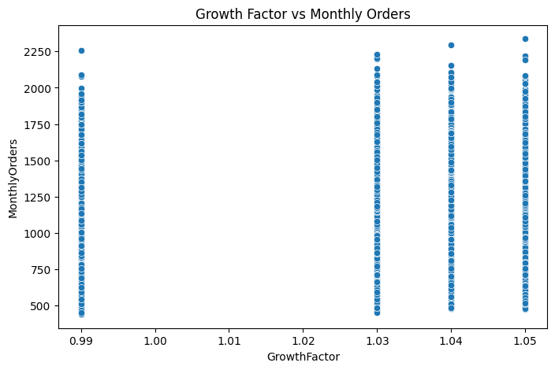

The scatter plot illustrates the relationship between Growth Factor and Monthly Orders across restaurants. Growth Factor values are concentrated around a few discrete levels, while monthly orders exhibit a wide range of values from approximately 450 to 2,350 orders. The absence of a clear upward or downward pattern suggests that there is no strong direct relationship between Growth Factor and order volume. Restaurants with similar growth factors can experience significantly different levels of demand, indicating that additional factors such as pricing, location, cuisine type, and channel mix also influence monthly orders. Overall, the chart highlights the complexity of demand dynamics within the restaurant industry.
Distribution of Average Order Value Across Restaurant Segments
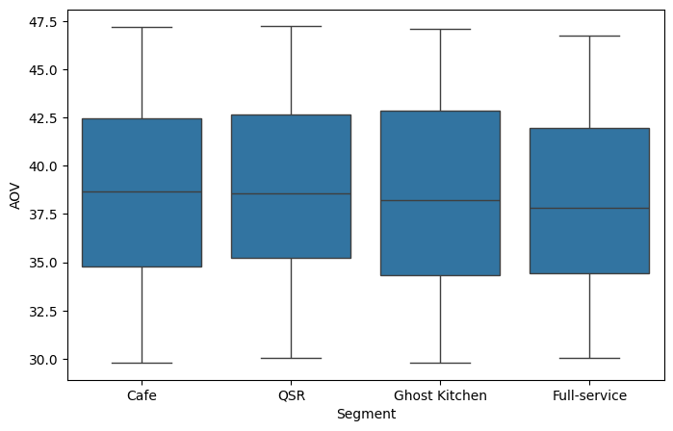
The box plot compares the distribution of Average Order Value (AOV) across different restaurant segments, including Cafes, QSRs, Ghost Kitchens, and Full-Service restaurants. The median AOV values are relatively similar across all segments, indicating that customer spending patterns are fairly consistent regardless of business format. The interquartile ranges are also comparable, suggesting a similar degree of variability in order values among the segments. Furthermore, no significant outliers are observed, implying that extreme AOV values are uncommon, Overall, the chart suggests that restaurant segment has only a limited influence on average order value, with most segments exhibiting comparable pricing behaviour.
Distribution of Monthly Orders Across Cuisine Types
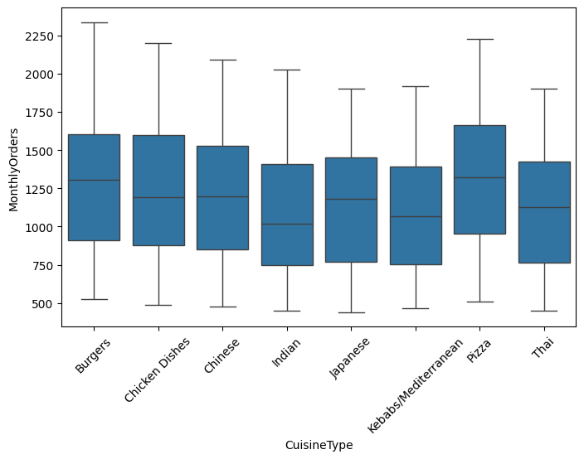

The box plot compares the distribution of Monthly Orders across different cuisine types. While all cuisine categories exhibit considerable variability in order volumes, Pizza and Burger restaurants tend to have slightly higher median monthly orders, indicating stronger customer demand. In contrast, cuisines such as Indian, Japanese, and Thai show relatively lower median order volumes. The wide interquartile range across all categories suggest substantial differences in restaurant performance within each cuisine segment. Overall, the chart highlights that customer demand varies across cuisine types, making cuisine an important factor to consider when analyzing restaurant profitability and market opportunities

CORRELATION ANALYSIS
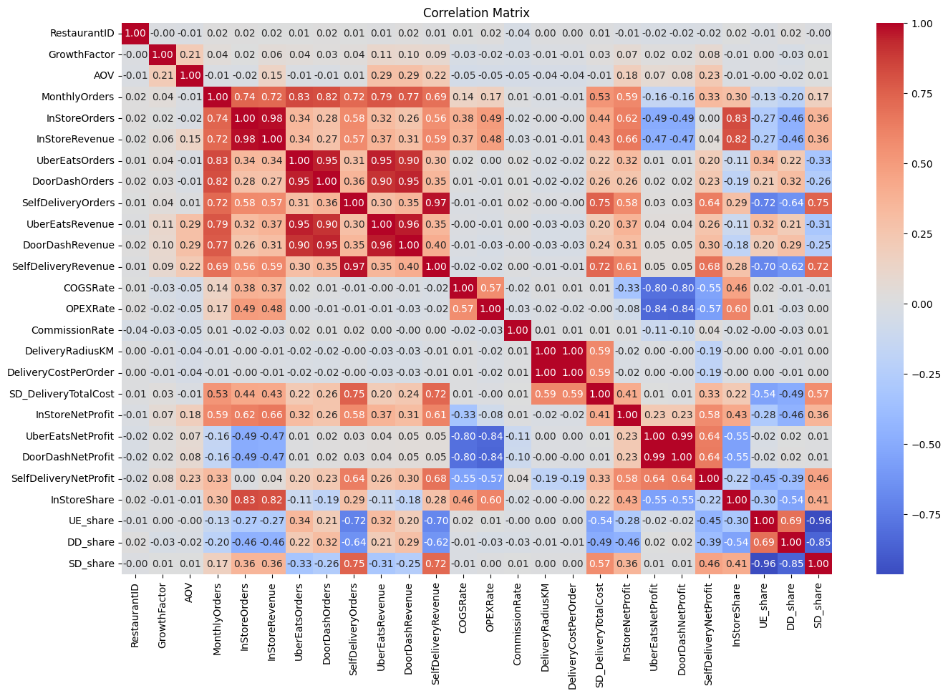

The correlation matrix provides a comprehensive view of the relationships among the numerical variables in the dataset. Strong positive correlations are observed between order volumes and their corresponding revenues, indicating that higher customer demand directly translates into increased sales. Monthly Orders exhibit strong positive relationship with In-Store, Uber Eats, DoorDash and Self-Delivery orders. Highlighting their importance as a key driver of business performance.

Revenue variables are also highly correlated with their respective profit measures, while channel share variables show strong negative correlations with one another, reflecting the trade-off between different sales channels. Cost-related variables, such as COGS and OPEX rates, generally display negative correlations with profitability indicating that higher operating costs reduce profits. Overall, the correlation analysis helps identify the most influential variables, detect multicollinearity, and provide valuable insights for feature selection and predictive modelling.

Revenue Distribution Across Sales Channels
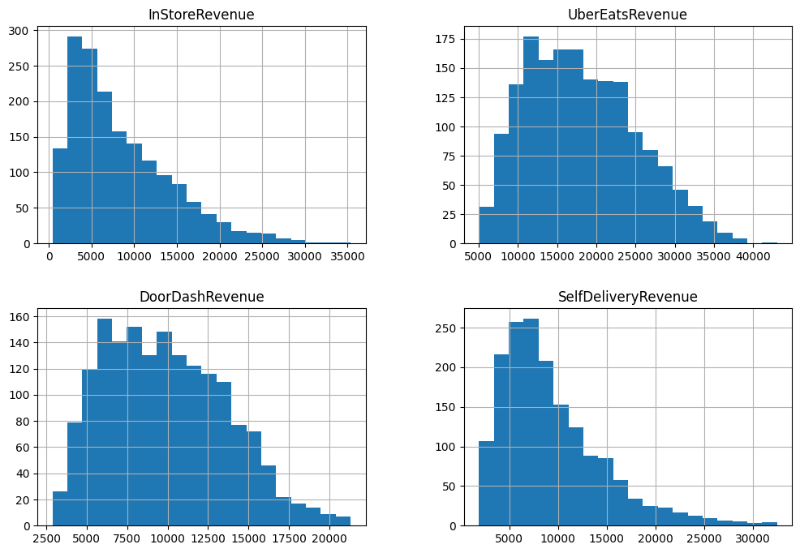
The histograms illustrate the distribution of revenues generated through the four sales channels: In-Store, Uber Eats, DoorDash and Self-Delivery. All four distributions exhibit a right-skewed pattern, indicating that while most restaurants generate moderate revenue labels, a smaller number achieve substantially higher revenues.
Among the channels, Uber Eats tends to generate the highest revenue values, followed by In-Store, whereas DoorDash and Self-Delivery generally produce comparatively lower revenues. The presence of long right tails suggests considerable variability in restaurant performance across channels. These distributions highlight the importance of channel mix in determining overall revenue and provide valuable insights for optimizing sales strategies and maximizing profitability.

Comparison of Revenue Distributions Across Sales Channels

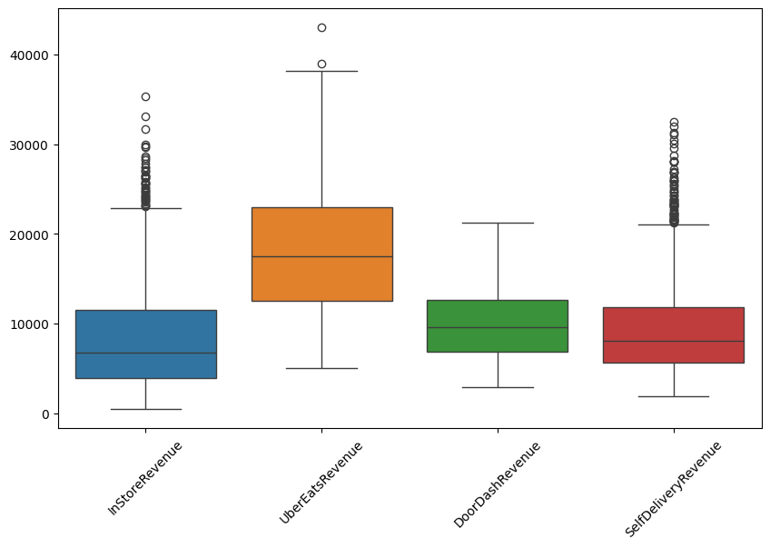

The box plot compares the revenue distributions of the four sales channels: In-Store, Uber Eats, DoorDash and Self-Delivery. Uber Eats exhibits the highest median revenue and the widest spread indicating that it generally generates higher revenues but also shows greater variability across restaurants. DoorDash and Self-Delivery have comparatively lower median revenues, while In-Store revenues display moderate variability. All channels contain several high-value outliers, suggesting that a subset of restaurants significantly outperforms others in terms of revenue generation. Overall, the chart highlights notable differences in revenue patterns across channels and emphasizes the importance of channel mix in driving overall restaurant performance and profitability.

Distribution of Total Revenue
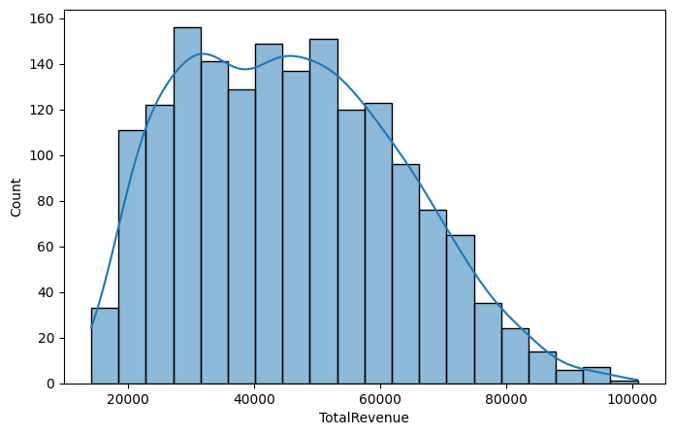

The histogram illustrates the distribution of Total Revenue across restaurants in the dataset. The distribution is positively skewed, with most restaurants generating revenues between 20,000 and 60,000, while a smaller number of restaurants achieve substantially higher revenues exceeding 80,000. The presence of a long right tail indicates considerable variation in revenue performance among restaurants. This pattern suggests that although the majority of restaurants operate within a moderate revenue range, a few high-performing establishments contribute disproportionately to overall sales. Understanding the distribution of total revenue is essential for identifying top-performing restaurants and developing strategies to enhance business growth and profitability.

Distribution of Total Net Profit:
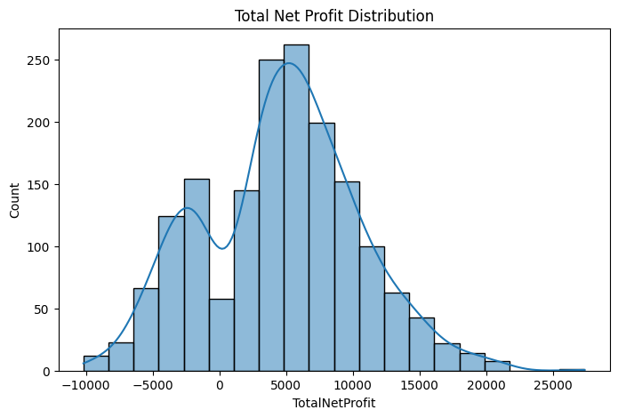

The histogram illustrates the distribution of Total Net Profit across restaurants in the dataset. The distribution is moderately right-skewed, with most restaurants generating profits between 0 and 10,000, while a smaller number achieve significantly higher profits exceeding 15,000. The presence of some negative profit values indicates that certain restaurants operate at a loss. The long right tail and wide spread suggest considerable variability in profitability among restaurants. Overall, the chart highlights differences in financial performance across the restaurant portfolio and emphasizes the importance of identifying the factors that drive profitability and improving the performance of underperforming establishments.
Comparison of Net Profit Across Sales Channels
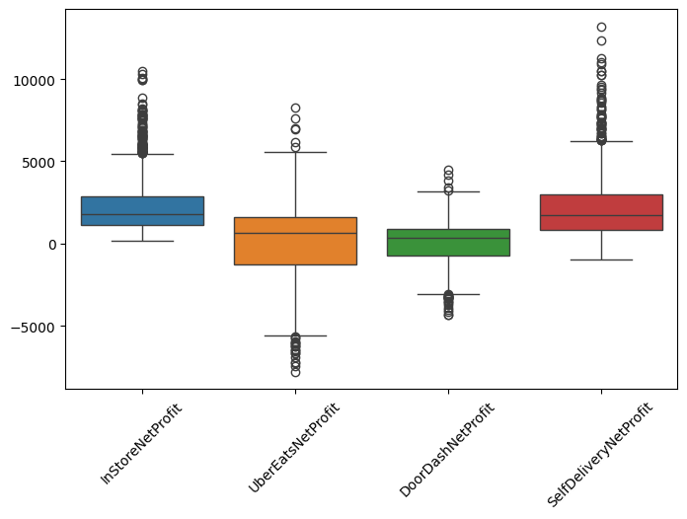
The box plot compares the distribution of Net Profit across the four sales channels: In-Store, Uber Eats, DoorDash, and Self-Delivery. Self-Delivery and In-Store channels exhibit the highest median profits, indicating stronger profitability compared to third-party delivery platforms. In contrast, Uber Eats and DoorDash show lower median profits and a greater number of negative profit values, suggesting that commission fees and operational costs may adversely affect profitability. All channels contain several outliers, highlighting the presence of restaurants that significantly outperform or underperform the average. Overall, the chart suggests that self-managed channels tend to be more profitable, while aggregator-based channels display greater variability and risk in financial performance.

Distribution of Sales Channel shares
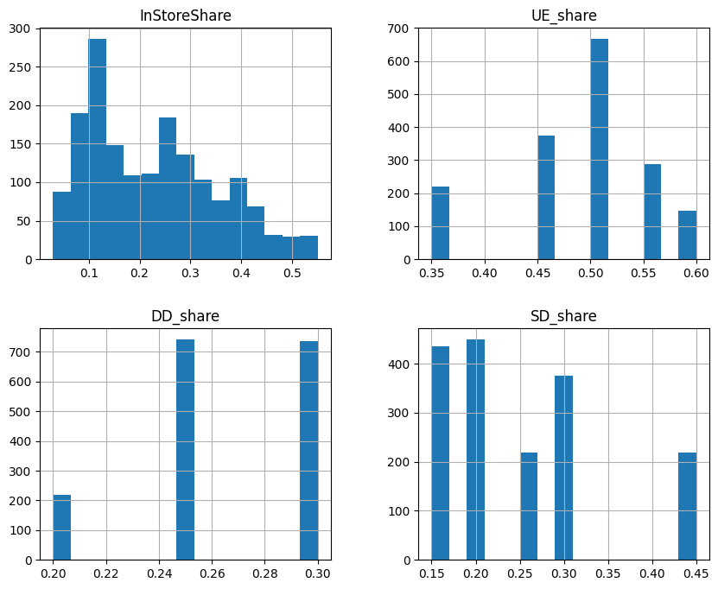
The histograms illustrate the distribution of revenue shares across the four sales channels: In-Store, Uber Eats, DoorDash, and Self-Delivery. The Uber Eats share is concentrated around higher values, indicating that many restaurants rely heavily on this platform for generating sales. DoorDash shares are generally lower and exhibit less variation across restaurants. Self-Delivery and In-Store shares show a wider spread, suggesting considerable differences in channel strategies among restaurants. The variation in channel proportions highlights the diverse operating models within the dataset and suggests that channel mix plays an important role in determining revenue generation and overall profitability.

Average Channel Share Comparison
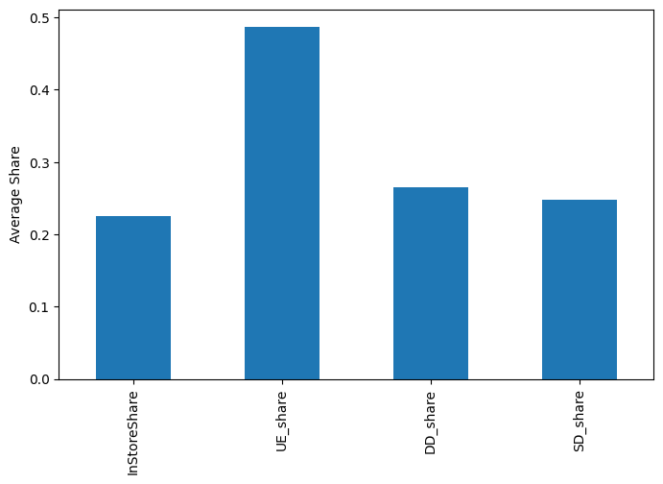

The bar chart compares the average revenue share contributed by the four sales channels: In-Store, Uber Eats, DoorDash, and Self-Delivery. Uber Eats accounts for the largest share, contributing nearly half of the total sales on average, making the dominant channel in the dataset. DoorDash and Self-Delivery contribute similar proportions, while In-Store sales represent the smallest average share. These results indicate that restaurants rely heavily on third-party delivery platforms, particularly Uber Eats, for revenue generation. Understanding the channel mix is essential for optimizing operations, managing commission costs, and improving overall profitability.

Revenue Share by Sales Channel
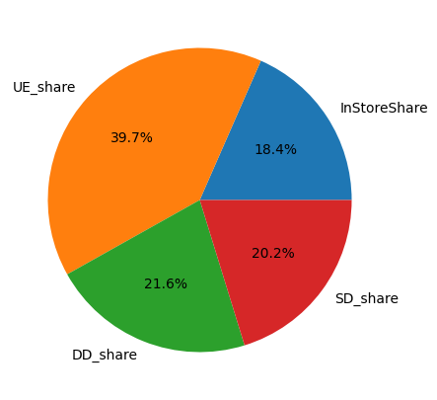

The pie chart illustrates the proportion of average sales contributed by each channel. Uber Eats represents the largest share, accounting for approximately 39.7% of total sales, making it the most important revenue source among the channels. DoorDash contributes around 21%, followed closely by Self-Delivery at 20.2%, while In-Store sales account for the smallest proportion at 18.4%. These results indicate that restaurants in the dataset rely heavily on online delivery platforms, particularly Uber Eats, for revenue generation. The channel mix highlights the growing importance of delivery services and suggests that effective management of platform commissions and delivery operations is critical for maximizing profitability.

OUTLIER DETECTION:
Outlier Distribution of Average Order Value (AOV)
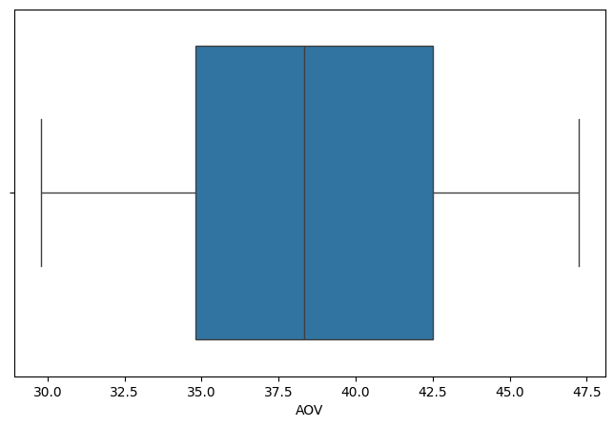

The box plot summarizes the distribution of Average Order Value (AOV) across restaurants. The median AOV is approximately $39, indicating that half of the restaurants have average order values above this level and half below. The interquartile range lies roughly between $35 and $43, suggesting moderate variability in customer spending patterns. The whiskers extend from about $30 to $47, showing the overall range of AOV values in the dataset. The absence of significant outliers indicates that average order values are relatively consistent across restaurants. Overall, the chart suggests a stable pricing structure and fairly uniform customer spending behaviour among the establishments studied.

Outlier Distribution of Monthly Orders
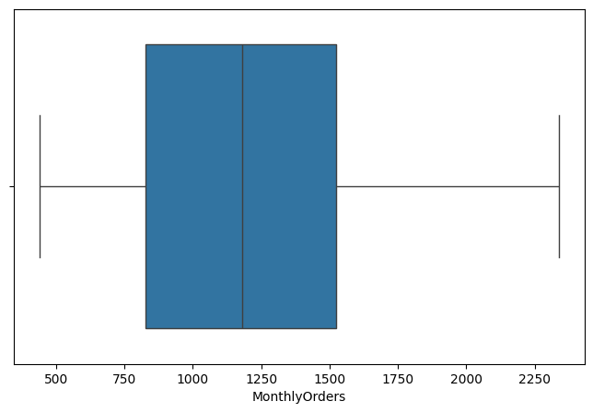

The box plot summarizes the distribution of Monthly Orders across restaurants in the dataset. The median number of monthly orders is approximately 1,200, indicating that half of the restaurants receive more orders and half receive fewer. The interquartile range extends from roughly 850 to 1,500 orders, suggesting moderate variability in demand among restaurants. The whiskers span from around 450 to 2,350 orders, reflecting a wide range of order volumes across establishments. The absence of significant outliers indicates that extreme order counts are uncommon. Overall, the chart suggests that while customer demand varies considerably among restaurants, most establishments operate within a fairly consistent range of monthly order volumes.

Outlier Distribution of Delivery Cost Per order
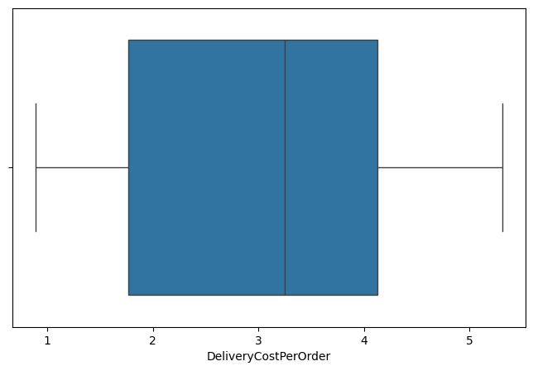

The box plot summarizes the distribution of Delivery Cost per Order across restaurants. The median delivery cost is approximately $3.3, indicating that half of the restaurants incur delivery costs above this value and half below. The interquartile range extends from roughly $1.8 to $4.2, reflecting moderate variability in delivery expenses among restaurants. The overall range spans from about $0.9 to $5.5, suggesting differences in delivery operations and service areas. The absence of significant outliers indicates that delivery costs are relatively consistent across the dataset. Overall, the chart suggests that most restaurants operate within a similar delivery cost structure, making delivery expenses an important factor influencing overall profitability.

Outlier Distribution of Commission Rate:
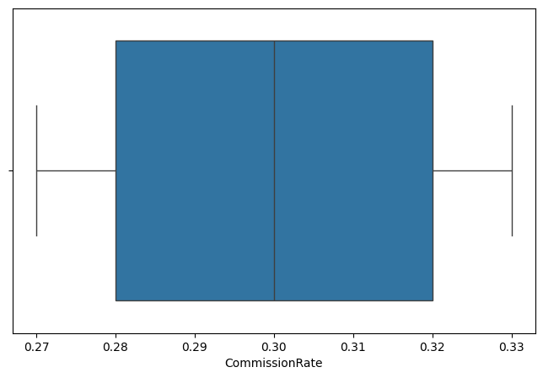

The box plot presents the distribution of Commission Rates charged across restaurants and delivery platforms. The median commission rate is approximately 30%, with the interquartile range extending from around 28% to 32%, indicating relatively low variability in commission structures. The whiskers span from roughly 27% to 33%, showing that most restaurants operate within a narrow range of commission rates. The absence of significant outliers suggest a consistent pricing structure across the dataset. Overall, the chart indicates that commission rates are fairly standardized, implying that differences in restaurant profitability are likely influenced more by factors such as order volume, channel mix, and operating costs rather than variations in commission percentages alone.

Business Insights Extraction
Average Net Profit Across Sales Channels
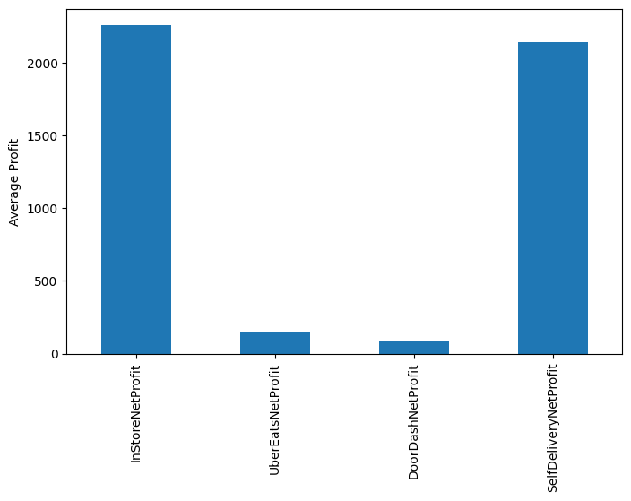

The bar chart compares the average net profit generated by the four sales channels. In-Store and Self-Delivery channels contribute the highest average profits, with values exceeding 2,000, indicating that these channels are the most profitable for restaurants. In contrast, Uber Eats and DoorDash generate substantially lower average profits, primarily due to platform commissions fees and associated operating costs. Among the third-party platforms, Uber Eats performs slightly better than DoorDash. Overall, the chart suggests that restaurants achieve greater profitability through direct channels, while aggregator-based channels, although important for revenue generation, provide comparatively lower profit margins.

Relationship between Commission Rate and Uber Eats Net Profit.
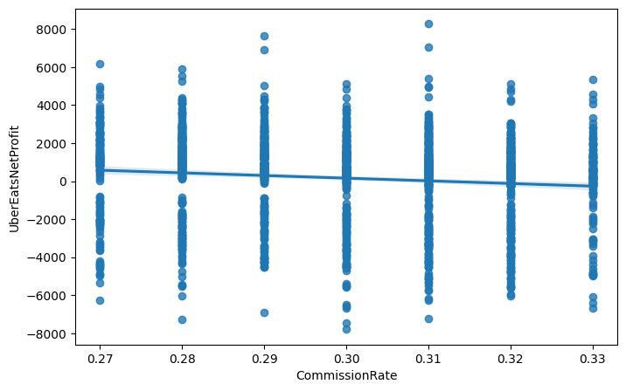

The scatter plot illustrates the relationship between Commission Rate and Uber Eats Net Profit. A slight downward trend is observed, as indicated by the fitted regression line, suggesting a weak negative relationship between the two variables. As commission rates increase, Uber Eats profitability tends to decline marginally due to higher platform fees. However, the wide dispersion of data points and the presence of both positive and negative profits at every commission level indicate that commission rate alone does not fully explain profitability. Other factors, such as order volume, average order value and operational efficiency also play a significant role in determining Uber Eats performance. Overall, the chart suggests that higher commissions can adversely affect profits, although the impact is relatively modest compared to other business drivers.

Relationship between Delivery Cost and Self-Delivery Net Profit

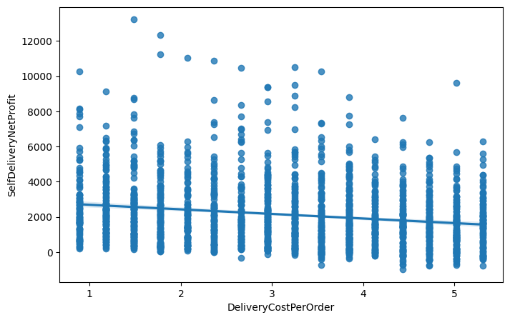

The scatter plot illustrates the relationship between Delivery Cost per Order and Self-Delivery Net Profit. The fitted regression line exhibits a negative slope, indicating that higher delivery costs are generally associated with lower self-delivery profitability. As delivery expenses increase, the profit generated through the self-delivery channel tends to decline due to the additional operational burden. Although the data points are widely dispersed, suggesting considerable variability among restaurants, the overall downward trend highlights the importance of controlling delivery costs to maintain healthy profit margins. The presence of several high-profit observations also suggests that factors such as order volume and pricing strategy can partially offset the impact of rising delivery expenses. Overall, the chart demonstrates that delivery cost is an important determinant of self-delivery profitability.

- FEATURE ENGINEERING
Feature engineering was performed to create additional variables that better capture customer behaviour, channel characteristics, and operational efficiency. These derived features provide richer information to machine learning models and improve prediction accuracy for restaurant profitability

- Revenue Share Features
To understand the contribution of each channel to overall sales, the following features were created:

Uber Eats Share
[UE_share=\frac{UberEatsRevenue}{TotalRevenue}]
DoorDash Share
[DD_share=\frac{DoorDashRevenue}{TotalRevenue}]
Self-Delivery Share
[SD_share=\frac{SelfDeliveryRevenue}{TotalRevenue}]
In-Store Share
[InStoreShare=\frac{InStoreRevenue}{TotalRevenue}]
Need: These variables measure channel dependence and help determine how the sales mix affects profitability.

2. Revenue Ratio Features
Uber Eats Revenue Ratio
[UE_RevRatio=\frac{UberEatsRevenue}{TotalRevenue}]
DoorDash Revenue Ratio
[DD_RevRatio=\frac{DoorDashRevenue}{TotalRevenue}]
Self-Delivery Revenue Ratio
[SD_RevRatio=\frac{SelfDeliveryRevenue}{TotalRevenue}]
In-Store Revenue Ratio
[InStore_RevRatio=\frac{InStoreRevenue}{TotalRevenue}]
Aggregator Revenue Ratio
[Aggregator_RevRatio=\frac{UberEatsRevenue+DoorDashRevenue}{TotalRevenue}]
Need: These features quantify the relative contribution of each channel and the overall reliance on third-party platforms.

3. Delivery Cost Ratio
[DeliveryCostRatio=\frac{SD_DeliveryTotalCost}{TotalRevenue}]
Need: Measures how much of the total revenue is consumed by delivery expenses.

4. Profit Margin
[ProfitMargin=\frac{TotalNetProfit}{TotalRevenue}]
Need: Represents overall operational efficiency and profitability.

5. Revenue Per Order
[RevenuePerOrder=\frac{TotalRevenue}{MonthlyOrders}]
Need: Indicates the average revenue generated from each customer order.

6. Self-Delivery Profit Per Order
[SD_ProfitPerOrder=\frac{SelfDeliveryNetProfit}{SelfDeliveryOrders}]
Need: Evaluates the profitability of each self-delivery order.

7. Aggregator Profit
[AggregatorProfit=UberEatsNetProfit+DoorDashNetProfit]
Need: Measures the combined profitability of third-party delivery platforms.
8. Total Delivery Orders
[
TotalDeliveryOrders=
UberEatsOrders+
DoorDashOrders+
SelfDeliveryOrders
]
Need: Captures the total delivery demand across all channels.
9. Delivery Order Ratio
[DeliveryOrderRatio=\frac{TotalDeliveryOrders}{MonthlyOrders}]
Need: Measures the proportion of orders fulfilled through delivery channels.
0. Commission Interaction Features
Commission Impact on Uber Eats
[Commission_UE=CommissionRate \times UE_share]
Commission Impact on DoorDash
[Commission_DD=CommissionRate \times DD_share]
Need: Captures the combined effect of commission rates and platform dependence on profitability.

11. Self-Delivery Cost Interaction
[SD_Cost_Interaction=DeliveryCostPerOrder \times SD_share]
Need: Measures how delivery costs affect restaurants that rely heavily on self-delivery.

12. Radius and Self-Delivery Interaction
[Radius_SD=DeliveryRadiusKM \times SD_share]
Need: Captures the effect of delivery distance on self-delivery operations.

13. Adjusted Demand
[AdjustedDemand=MonthlyOrders \times GrowthFactor]
Need: Represents future expected demand by incorporating growth potential into current order volume.

14. Aggregator Share
[AggregatorShare=UE_share+DD_share]
Need: Indicates the overall dependence on third-party delivery platforms.

Feature Engineering transformed the raw transactional data into meaningful business indicators that describe customer demand, channel dependence, cost structure, and operational efficiency. These engineered variables helped the machine learning models capture complex relationships within the data and significantly improved the accuracy and
Interpretability of restaurant profit predictions.

- Predictive Modelling
The Objective of predictive modelling phase was to develop machine learning models capable of accurately predicting the Total Monthly Net Profit of restaurants. This phase aimed to identify the key factors influencing profitability and provide a foundation for optimization and scenario analysis.

Target Variable:
The primary target variable selected for prediction was
TotalNetProfit.
Which represents the overall monthly net profit generated by each restaurant.

The independent variables consisted of restaurant characteristics, operational variables, delivery channel shares, and engineered features developed during the preprocessing stage.

Train-Test Split:
To evaluate model performance on unseen data, the dataset was divided into training and testing subsets using an 80:20 ratio.

The split was performed using the following configuration:
- Training data: 80%
- Testing data: 20%
- Random state: 42
This approach ensured that the models were trained on the majority of observations while reserving a separate dataset for unbiased performance evaluation.
Model 1: Linear Regression

Linear Regression is a simple statistical model that estimates the relationship between predictor variables and the target variable.

Linear Regression was used as a baseline model because of its simplicity and interpretability.
Advantages:
- Easy to interpret.
- Provides coefficients that explain the impact of each variable on profitability.
- Useful for managerial decision-making.

Model 2: Random Forest Regressor
Random Forest is an ensemble learning method that constructs multiple decision trees and averages their predictions.
Random Forest was employed to capture nonlinear patterns and interactions among variables
RandomForestRegresor(
n_estimators=300,
max_depth = 10,
random_state=42)
n_estimators = Number of trees in the forest
max_depth = maximum tree depth
random_state = ensures reproducibility

Advantages:
- Handles nonlinear relationships effectively
- Reduces overfitting through ensemble learning
- Automatically captures variable interactions
- Robust to noise and outliers

Model 3: Gradient Boosting Regressor
Gradient Boosting sequentially builds decision trees by correcting the errors made by previous trees.
Gradient Boosting was implemented to further enhance predictive performance by sequentially correcting prediction errors.
GradientBoostingRegressor(
n_estimators = 200,
learning_rate = 0.05,
random_state = 42)

n_estimators = no of boosting stages
learning_rate = shrinks contribution of each tree
random_state = ensures reproducibility
Advantages:
Captures complex nonlinear relationships.
Learns intricate patterns in the data.
Provides high prediction accuracy.
Handles margin effects and subtle interactions among variables.

Model 4: XGBoost Regressor
Extreme Gradient Boosting(XGBoost) is an advanced ensemble algorithm that uses gradient boosting with regularization.
XGBoost Regressor was employed as the final advanced model due to its superior predictive power and computational efficiency.

XGBRegressor(
n_estimators=300,
learning_rate = 0.05,
max_depth = 5,
random_state = 42)

n_estimators= no of boosting trees
learning_rate = controls contribution of each tree
max_depth = maximum tree depth
random_state = ensures reproducibility

Advantages:
  - Captures nonlinear effects.
  - Models interaction effects among variables.
  - Detects cost thresholds and demand patterns.
  - Provides excellent generalization performance.
  - Handles complex business relationships effectively.

- Model Evaluation
The objective of the model evaluation phase was to capture the predictive performance of the different machine learning models developed for forecasting Total Monthly Net Profit. The models were evaluated on the testing dataset using standard regression performance metrics to assess prediction accuracy, robustness, and explanatory power.

Evaluation Metrics:

Root Mean Squared Error (RMSE)
Root Mean Squared Error(RMSE) measures the average magnitude of prediction errors. It penalizes large errors more heavily and provides an indication of how closely the predicted values match the actual values.

[RMSE=\sqrt{Mean\ Squared\ Error}]
Lower RMSE values indicate better model performance and higher prediction accuracy.

Mean Absolute Error (MAE)
Mean Absolute Error(MAE) measures the average absolute difference between predicted and actual values.

[MAE=\frac{1}{n}\sum |Actual-Predicted|]
MAE is less sensitive to extreme observations and provides a robust measure of prediction accuracy.

Lower MAE values indicate better predictive performance.

Coefficient of Determination (R²)

The coefficient of determination, denoted by R², measures the proportion of variability in the target variable explained by the model.
[R^2=
1-
\frac{SS_{Residual}}
{SS_{Total}}]

Higher R² values indicate that the model explains a larger proportion of the variance in restaurant profitability.

Model Comparison:
The performance of the four models is summarized below.

Model | RMSE | MAE | R²
Linear Regression | 2603.36 | 1984.64 | 0.7893
Random Forest | 2188.89 | 1675.36 | 0.8510
Gradient Boosting | 2108.55 | 1624.72 | 0.8618
XGBoost | 2147.92 | 1644.10 | 0.8566

Performance Analysis:

Linear Regression: LR served as the baseline model and achieved an R² value of approximately 78.9%. Although the model provided interpretable coefficients, its prediction errors were relatively large, indicating limited ability to capture the complex nonlinear relationships present in restaurant profitability.

Random Forest Regressor: RFR significantly improved predictive performance over Linear Regression. The ensemble approach successfully captured non-linear patterns and interactions among variables, leading to lower prediction errors and a higher R² value of 85.1%

Gradient Boosting Regressor: GBR achieved the best overall performance among all models. It produced the lowest RMSE(2108.55) and MAE(1624.72), while explaining approximately 86.2% of the variance in Total Net Profit. The model effectively captured complex relationships and subtle interaction effects among operational variables.

XGBoost Regressor: XGB also demonstrated strong predictive capability with an R² value of 85.7%. Although its performance was slightly below that of Gradient Boosting in terms of RMSE and MAE, it remained highly competitive and offered advantages such as regularization, scalability, and computational efficiency.

Best Model Selection:

Model selection was based on the following criteria:
Lowest RMSE
Lowest MAE
Highest R²

Based on three evaluation metrics, the Gradient Boosting Regressor emerged as the best-performing model, achieving:

- RMSE = 2108.55
- MAE = 1624.72
- R² = 0.8618
The model explained approximately 86% of the variation in restaurant profitability and provided the highest prediction accuracy among all models considered.
Consequently, the Gradient Boosting model was selected as the final predictive model and served as the foundation for subsequent analyses, including profit prediction, scenario analysis, sensitivity analysis, Monte Carlo simulation, channel optimization and the executive recommendation engine.
Overall the model evaluation phase demonstrated that ensemble-based machine learning algorithms significantly outperform traditional linear regression models when predicting restaurant profitability, highlighting the importance of capturing nonlinear relationships and interaction effects in complex business environments.

Feature Importance Analysis for Total Net Profit
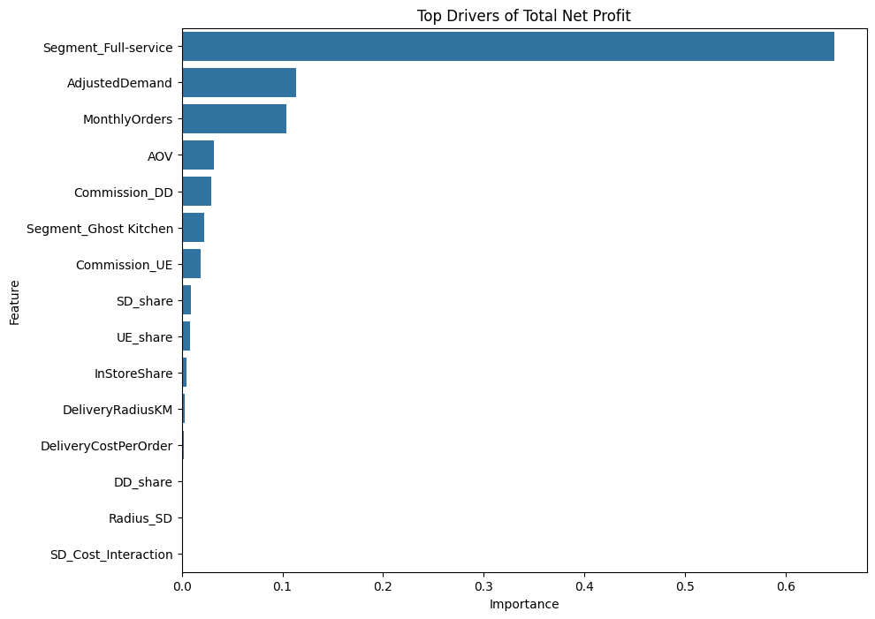
The feature importance chart presents the most influential variables affecting Total Monthly Net Profit as identified by the machine learning model. Among all predictors, Segment_Full-service emerged as the dominant factor, accounting for the largest contribution to profitability. This indicates that the restaurant business segment plays a crucial role in determining overall financial performance.
The second and third most important variables are AdjustedDemand and MonthlyOrders, highlighting the significance of customer demand and order volume in driving profits. Restaurants with higher demand and greater order frequency tend to generate superior financial outcomes.
Moderate importance is observed for variables such as Average Order Value (AOV), Commission_DD, Commission_UE, and Segment_Ghost Kitchen, suggesting that pricing strategy and platform commission structures also influence profitability. Features related to delivery channel shares, delivery radius, and delivery costs exhibit relatively low importance, implying that these factors have a comparatively smaller impact on total net profit.
Overall the analysis indicates that restaurant segment characteristics and demand-related variables are the primary drivers of profitability, whereas operational delivery variables contribute less to profit variation. These insights can assist management in focusing strategic efforts on increasing customer demand and optimizing business models to maximize profitability.

Actual vs Predicted Values:
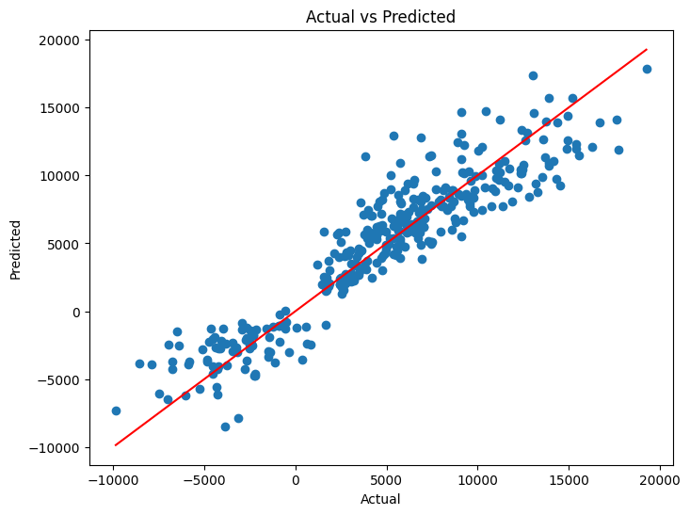
The scatter plot compares the actual Total Net Profit values with the values predicted by the machine learning model. The red diagonal line represents the ideal situation where predicted values exactly match the actual values. Most of the observations are clustered closely around this line, indicating a strong agreement between the actual and predicted profits and demonstrating good model performance.
Although a few points deviate from the reference line, suggesting some prediction errors for certain restaurants, the overall pattern shows a strong positive relationship between actual and predicted values. This indicates that the model is capable of capturing the underlying relationships within the data and provides reliable profit estimates. The close alignment of the observations with the diagonal line further confirms the high predictive accuracy achieved during the model evaluation phase.

- Advance Model Evaluation and Explainability
To further assess the robustness and generalization capability of the selected model, advanced evaluation techniques including K-Fold Cross Validation and Hyperparameter Tuning were performed.
K-Fold Cross Validation
Five-fold cross validation was applied to evaluate the consistency of the model across different subsets of the data. The dataset was randomly divided into five equal folds, where four folds were used for training and the remaining fold was used for testing. This process was repeated five times so that each fold served as the best set once.
Cross-validation scores obtained using the R² metric were
Fold | R² Score
1 | 0.8617
2 | 0.8810
3 | 0.9004
4 | 0.9012
5 | 0.8902

The consistently high R² values indicate that the model performs well across different samples and exhibits strong generalization ability with minimal overfitting.

Hyperparameter Tuning Using Grid Search
To further improve model performance, hyperparameter optimization was carried out using GridSearchCV. A combination of different values for the key GradientBoosting parameters was evaluated through five-fold cross validation.
param_grid = {
'n_estimators': [100,200,300],
'max_depth': [3,5,7],
'learning_rate':[0.01,0.05,0.1]
}
The Grid Search procedure systematically explored all possible parameter combinations and selected the configuration that maximized the R² score.
grid = GridSearchCV(
estimator = GradientBoostingRegressor(random_state=42),
param_grid = param_grid,
cv=5,
scoring='r2',
verbose=1
)
Best Hyperparameters
The optimal parameter combination identified by Grid Search was: learning_rate : 0.05, max_depth=3 & n_estimators = 200

Model Explainability:
Advanced evaluation techniques confirmed that the model is stable and capable of producing reliable prediction across different data partitions. The Optimized Gradient Boost model effectively captures non-linear relationships and interaction effects among variables while maintaining strong predictive performance.
The cross-validation results demonstrated that approximately 86-90% of the variation in restaurant profitability can be explained by the model. Hyperparameter tuning further enhanced model accuracy and reduced the risk of overfitting.
Overall, the advanced evaluation and explainability phase validated the robustness of the predictive model and provided confidence in its use for subsequent business applications, including what-if analysis, Monte Carlo simulation, channel optimization, and executive recommendation generation

SHAP Explainability Analysis
SHAP was employed to interpret the predictions of the machine learning model and quantify the contribution of individual features to Total Net Profit. The SHAP summary plot ranks features according to their overall importance and illustrates both the magnitude and direction of their impact on model predictions.
The analysis reveals the Segment_Full-service is the most influential feature, indicating that the restaurant business format has the strongest effect on profitability. Monthly Orders and Average Order Value (AOV) are the next most important drivers, demonstrating that higher customer demand and larger order values contribute positively to net profit. Features such as Segment_Ghost Kitchen, Commission Rate and the various delivery channel shares exhibit moderate influence, while factors related to cuisine type and subregion have relatively limited impact.
The color scale represents the feature values, where red indicates higher values and blue indicates lower values. Points located on the right side of the plot contribute positively to predicted profit, whereas points on the left reduce the model output. The wide spread of SHAP values for the top variables highlights their substantial effect on profitability, while features clustered near zero have minimal influence.
Overall, the SHAP analysis enhances model transparency by explaining how individua variables affect predictions and confirms that restaurant segment, order volumes, and average order value are the primary drivers of restaurant profitability. This interpretability provides valuable insights for management and supports more informed business decision-making.

Residual Analysis

Residual Distribution Analysis
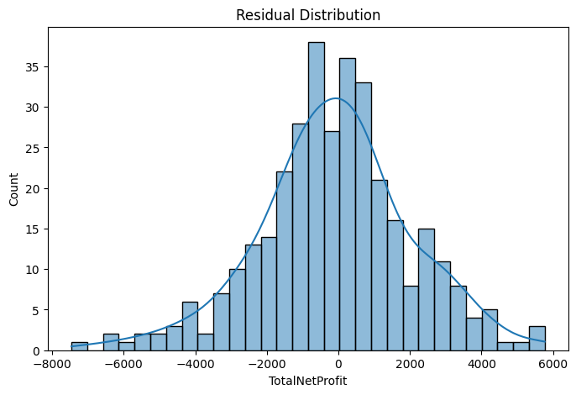
The residual distribution plot illustrates the frequency and spread of prediction errors generated by the machine learning model. Residuals represent the difference between the actual and predicted values of Total Net Profit. The histogram exhibits an approximately bell-shaped pattern centered around zero, indicating that the majority of prediction errors are relatively small and randomly distributed.
Most residuals are concentrated near zero, suggesting that the model produces accurate predictions for a large proportion of restaurants. The distribution is fairly symmetric, implying that the model does not systematically overestimate or underestimate profitability. A small number of extreme residuals are observed in both the positive and negative directions, corresponding to restaurants for which the prediction errors are comparatively larger.
Overall, the residual distribution demonstrates that the model is well calibrated and that the remaining prediction errors are largely random rather than resulting from systematic bias. This behavior supports the reliability of the model and confirms its suitability for forecasting restaurant profitability and supporting strategic decision-making.
Residual vs Predicted Value Analysis
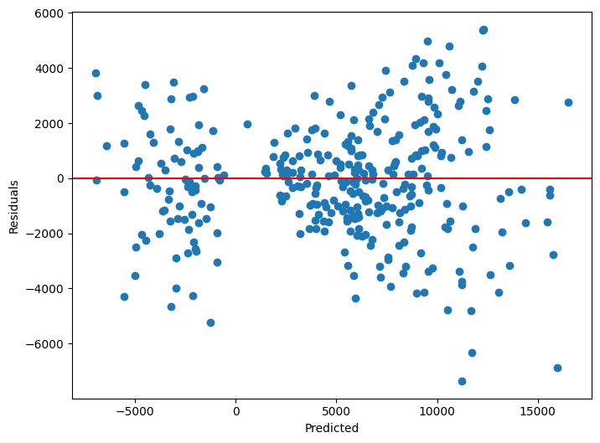
The residual versus predicted values plot provides a diagnostic assessment of the model’s performance by examining the distribution of prediction errors across different predicted profit levels. Residuals represent the difference between actual and predicted values, while the horizontal line at zero indicates perfect prediction.
The residuals are generally scattered around the zero line, suggesting that the model does not exhibit significant systematic bias and that predictions are reasonably accurate. Both positive and negative residuals are observed, indicating that the model occasionally overestimates and underestimates restaurant profits. Most residuals are concentrated near zero, demonstrating good predictive performance for the majority of observations.
However, the spread of residuals appear to increase slightly as predicted profit values become larger, indicating some degree of heteroscedasticity. This suggests that prediction errors tend to be more variable for restaurants with higher profit levels. A few extreme residuals are also present, representing observations where the model produces relatively larger errors.
Overall, the absence of clear patterns or trends in the residuals indicates that the model adequately captures the underlying relationship in the data. The random distribution of residuals around zero supports the validity of the model and confirms its suitability for forecasting restaurant profitability and supporting business decision-making.

Actual vs Predicted Value Analysis
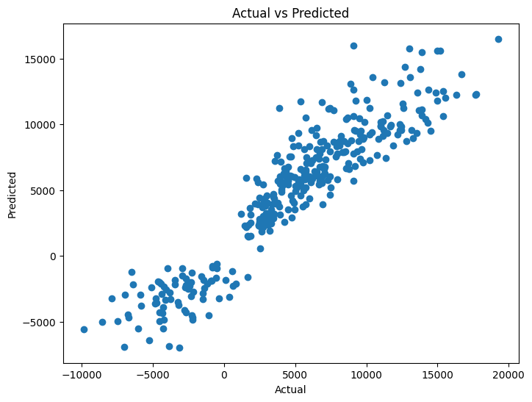

The scatter plot compares the actual values of Total Net Profit with the corresponding values predicted by the machine learning model. A strong positive linear relationship is observed, with the majority of data points closely clustered along the diagonal direction. This indicates that the model is able to accurately capture the underlying patterns in the data and produce reliable profit predictions.
Restaurants with higher actual profits generally correspond to higher predicted profits, demonstrating the model's ability to effectively estimate profitability across different performance levels. Although a few observations deviate from the overall trend, these represent instances where prediction errors are relatively larger. Nevertheless, the concentration of points around the diagonal suggests a high degree of agreement between actual and predicted values.
Overall, the chart provides visual evidence of the model's strong predictive performance and supports the high R² values obtained during model evaluation. The close correspondence between actual and predicted profits confirms that the model is well suited for forecasting restaurant profitability and can serve as a reliable foundation for subsequent optimization and decision-support analyses.

Business Interpretation:
Top Drivers of Net Profit:
Feature importance analysis reveals the key variables that have the greatest influence on restaurant profitability. Understanding these drivers provides valuable managerial insights and helps identify areas where strategic decisions can maximize profits.

- Segment_Full-service (Importance = 0.6489)
The restaurant segment emerged as the single most important determinant of profitability, contributing nearly 65% of the model’s predictive power. This indicates that full-service restaurants generally generate higher profits due to large average order values, enhanced customer experience, and diversified revenue streams. The business format itself plays a critical role in determining financial performance.

- Monthly Orders (Importance = 0.2195)
Monthly order volume is the second most influential factor affecting profitability. Restaurants with higher order volumes tend to generate greater revenues and benefit from economies of scale, leading to improved profit margins. Increasing customer demand and order frequency is therefore essential for long-term profitability.

- Average Order Value (AOV) (Importance = 0.0353)
Average Order Value contributes positively to profit generation. Restaurants with higher spending per customer are able to increase revenue without necessarily increasing operating costs. Upselling, combo meals, and premium menu offerings can therefore enhance profitability.

- Segment_Ghost Kitchen (Importance = 0.0219)
Ghost Kitchen operations also contribute to profitability, although to a lesser extent than full-service restaurants. Their lower overhead costs and delivery-focused model provide operational efficiencies that can improve financial performance.

- Delivery Channel Shares
The proportions of orders fulfilled through different channels influence overall profitability:

- Self-Delivery Share (0.0208)
- Uber Eats Share (0.0186)
- DoorDash Share (0.0123)
These results suggest that channel mix has a moderate impact on profit. Restaurants must carefully balance delivery platforms direct delivery operations to optimize margins.

- Commission Rate (Importance = 0.0074)
Commission rates charged by delivery platforms have a negative effect on profitability. Higher commissions reduce margins, highlighting the importance of negotiating favourable rates and encouraging customers to use lower-cost channels

- In-Store Share (Importance = 0.0056)
In-store sales contribute positively to profits because they avoid delivery costs and platform commissions. Increasing dine-in traffic and direct customer engagement can therefore improve overall profitability.
- Delivery Radius and Delivery Cost

- Delivery Radius (0.0038)
- Delivery Cost Per Order (0.0024)
These variables have relatively small importance, indicating that delivery-related costs are less influential than demand and restaurant segment. Nevertheless, efficient delivery operations remain important for maintaining margins.

- Cuisine Type and Geographic Location
Cuisine categories and subregions exhibit very low feature importance values. This suggests that difference in cuisine and location contribute relatively little explaining profitability compared with business format and customer demand. Profitability appears to depend more on operational efficiency and channel strategy than on the type of cuisine offered or geographic location.

Key Business Insights:
The feature importance analysis indicates that profitability is primarily driven by:
- Restaurant business model.
- Customer demand and order volume.
- Average spending per customer.
- Delivery channel mix.
- Commission structures.
In contrast, cuisine type and geographic location have relatively little influence on financial performance.
Overall, the results suggest that restaurants seeking to maximize profitability should focus on increasing customer demand, improving average order value, optimizing channel mix, and adopting business models that deliver superior operational efficiency. These findings provide valuable guidance for strategic decision-making and resource allocation within the restaurant industry.

Scenario Simulation Engine
The Scenario Simulation Engine represents the decision-support component of the project and enables the evaluation of various business strategies under different operating conditions. Multiple “what-if” scenarios were created to estimate the impact of changes in delivery channel mix, commission rates, delivery radius, and market growth on restaurant profitability.
Several business scenarios were examined, including increasing the Uber Eats share, varying platform commission rates, expanding delivery coverage, and analyzing the trade-off between growth and margins. For each scenario, the trained machine learning model was used to predict the resulting net profit and quantify the financial impact of the proposed changes.
To account for uncertainty and risk , a Monte Carlo Simulation was performed by running 10,000 randomized scenarios. Key variables such as commission rate, delivery cost, and growth factor were varied within realistic ranges to generate a distribution of possible profit outcomes. The simulation provided important risk metrics, including expected profit, worst-case profit, best-case profit, and 95% confidence interval.
The Scenario Stimulation Engine enables management to evaluate alternative strategies before implementation and supports data-driven decision-making under uncertain business conditions.

Sensitivity Analysis
Sensitivity analysis was conducted to determine how changes in key business variables affect restaurant profitability. A Profit Sensitivity Index (PSI) was computed to measure the change in profit resulting from variations in important operational parameters such as commission rate, delivery cost per order, and delivery radius.
The analysis quantified the responsiveness of profit to changes in these variables and identified which factors have the greatest influence on financial performance. Results were visualized using a Tornado Chart, which ranks variables according to their impact on profitability.
The sensitivity analysis revealed the most critical drivers of profit and highlighted areas where management interventions can have the greatest effect. This analysis provides valuable insights for strategic planning, risk assessment, and operational optimization by identifying variables that require close monitoring and control.

Optimization Layer:
The optimization layer was developed to determine the channel mix that maximizes total monthly net profit. The proportions of in-store sales, Uber Eats, DoorDash, and self-delivery were treated as decision variables, subject to the constraints that all channel shares must lie between 0 and 1 and collectively sum to one.
Optimization was performed using numerical techniques available in SciPy, where the objective function aimed to maximize the profit predicted by the machine learning model. The solution provided the optimal allocation of orders across channels and identified the most profitable channel mix for restaurant operations.
In addition, a break-even commission analysis was conducted to determine the commission rate at which profits generated through aggregator platforms become equal to profits obtained through self-delivery. This analysis provides valuable support for negotiating commission agreements with delivery platforms.

A self-delivery threshold analysis was also performed to identify the order volume at which self-delivery becomes more profitable than third-party delivery channels. This insight helps management decide when investing in self-delivery infrastructure is economically justified.
Finally, the effectiveness of optimization was measured through the Optimization Uplift metric, which compares optimized profit with current profit. The percentage improvement quantifies the financial benefits obtained through channel optimization and demonstrates the value of data-driven decision-making in maximizing restaurant profitability.

KPI Framework:
A comprehensive Key Performance Indicator (KPI) framework was developed to monitor restaurant performance and support managerial decision-making. Key metrics included predicted monthly net profit, profit per order, channel mix efficiency score, profit sensitivity index, break-even commission rate, and optimization uplift. These KPIs provide insights into profitability, operational efficiency, risk exposure and potential financial improvements. Together , they enable management to continuously evaluate business performance and identify opportunities for maximizing profitability.

Streamlit Dashboard:
An Interactive Streamlit dashboard was developed to provide a user-friendly decision-support system for restaurant managers. The dashboard integrates predictive analytics, scenario simulation, optimization, and risk assessment into a single platform.

The Executive Overview Module presents key business metrics such as revenue, profit, margins and order volumes. The Profit Prediction module allows users to estimate future profits based on operational inputs including commission rates, delivery radius, and channel shares. A What-If Analysis module enables users to explore the impact of changes in channel mix, growth factors, and commissions through real-time prediction updates.
Interactive visualizations, including tornado charts and
Heatmaps, were incorporated to analyse cost sensitivity and identify critical profit drivers. An Optimization Panel
compares the current strategy with the model-recommended strategy and quantifies the expected improvements in profitability. Finally, a Risk Analysis module employs Monte Carlo simulation to visualize profit distributions and confidence intervals, allowing management to assess uncertainty and make more informed strategic decisions.
Overall, the Streamlit dashboard transforms complex analytical results into accessible and interactive business intelligence tool, enabling data-driven decision-making and enhancing restaurant profitability management.

Conclusion:
This project successfully developed a comprehensive Restaurant Profit Optimization and Decision Support System by combining exploratory data analysis, feature engineering, machine learning, simulation, optimization and interactive visualization techniques. Using restaurant operational and financial data, predictive models were built to forecast Total Monthly Net Profit and identify the key factors influencing profitability.
Exploratory analysis revealed that restaurant segment, order volume, average order value, and channel mix are among the most important determinants of financial performance. Several machine learning algorithms were evaluated, with ensemble methods demonstrating superior predictive capability. Advanced validation techniques, including cross-validation and hyperparameter tuning, confirmed the robustness and reliability of the selected model.
Feature importance analysis and SHAP explainability provided valuable insights into the drivers of profitability, enhancing model transparency and supporting managerial interpretation. Scenario analysis, Monte Carlo simulation, and sensitivity analysis enabled the assessment of risk and uncertainty under varying business conditions. The optimization layer further identified the most profitable channel allocation strategies and quantified the potential improvement achievable through data-driven decision making.
The integration of these analytical components into an interactive Streamlit dashboard transformed the project into a practical business intelligence tool capable of supporting real-time strategic decisions. The dashboard allows managers to perform profit prediction, what-if analysis, risk assessment, channel optimization, and executive recommendations in a user-friendly environment.
Overall, the study demonstrates that machine learning and optimization techniques can effectively support restaurant profitability management by providing accurate forecasts, identifying critical business drivers, evaluating alternative scenarios, and recommending optimal operational strategies. The proposed framework offers a scalable and data-driven approach that can help restaurant operators improve efficiency, reduce risk, and maximize long-term profitability.

Future Scope:
Future enhancements may include the incorporation of real-time sales data, customer reviews, promotional campaigns, weather information, and seasonal effects to further improve prediction accuracy. Deep learning models, reinforcement learning, and advanced optimization techniques may also be explored to provide even more sophisticated decision-support capabilities. Additionally, the framework can be extended to support multiple restaurant chains and other sectors within the food service industry.

